Output for Assignment 1:

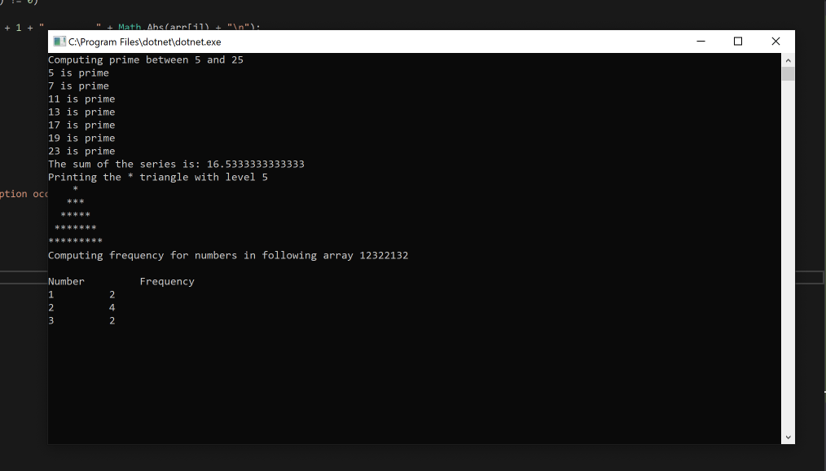

GitHub path :

<https://github.com/vishalsonawane11/Assignment-1_ISM_vishal-Sonawane.git>

Assignment-1_ISM_vishal-Sonawane/Assignment 1_ISM_vishal Sonawane/Program.cs